The PAGCA “Pottstown Show ™” for Spring 2023 Friday March 31 & Saturday April 1, 2023
( preliminary details)

The 2023 PAGCA 2-day “Pottstown Show™” will be held next year at the East Greenville Fire Hall located at 401 Washington St, East Greenville, PA 18041. Located about 10 miles North of Pottstown, PA on
Rt. 663. Access to the show is easiest by taking the Rt. 663 (Quakertown) exit East off the North East PA Tpk. Extension about 4 miles to East Greenville. Then turning right on to Main Street (Rt. 29) about 1 mile and then turning right on to 4th Street with the fire hall at the bottom of the street.

The preliminary plan is to have dealer set-up start at 9 am on Friday March 3 and the public admitted at 12 Noon to 5 or 6 pm. On Saturday April 1, the public would be admitted from 9 am to 4 pm at which time the show would close. Preliminary table price would be $70 and gate price would be $5 with those under 15 admitted free. PAGCA members in good standing would also be admitted free. The PAGCA “Pottstown Show™” show dates are set two weeks after the Baltimore show.

Advertising will be 2 or 3 insertions in Man-at-Arms magazine, flyer distribution at all major shows including Baltimore leading up to March 31, listing of the show on all internet show calendars, advertising in local papers, etc. in the Pottstown / Allentown area, flyers distributed in the East Greenville area and signage I possible in along Rt. 663. And of course on the PAGCA web site.

The photos below and on the back show the Fire Hall which is a premier facility with substantial parking,
a large hall holding at least 60 tables, quality tables and chairs, clean restroom facilities and possibly kitchen support. There is also a full stage at one end of the hall that could possibly used for display only tables. Credit for finding and helping secure the East Greenville Fire Hall, and the sincere thanks of the PAGCA officers goes to our member Dr. Doug Pfeiffer who suggested the hall and help explain to the Fire Fire House officers who the PAGCA is and our history. Thank you Doug!
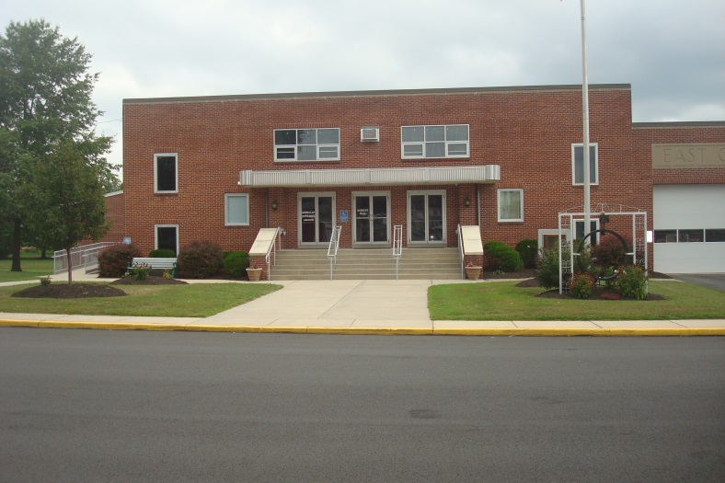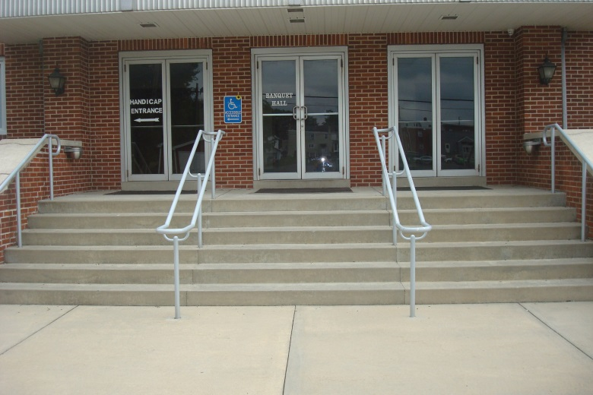

Hall with 40 bingo table set up w/ open space More Hall space and kitchen area on right
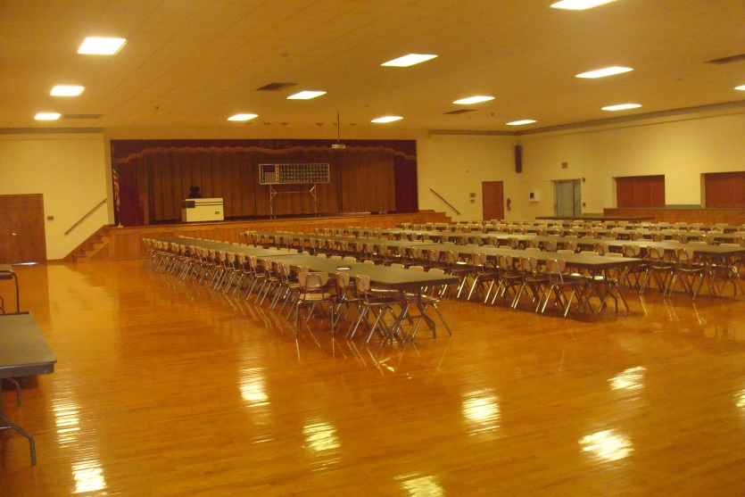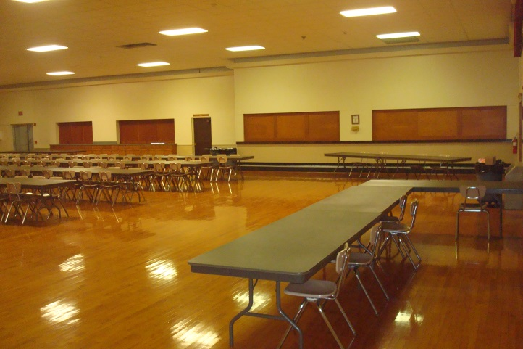

The PAGCA “Pottstown Show ™” for Spring 2023 Friday March 31 & Saturday April 1, 2023
( preliminary details)

Handicap and Dealer access ramp Primary parking Lot across from hall entrance
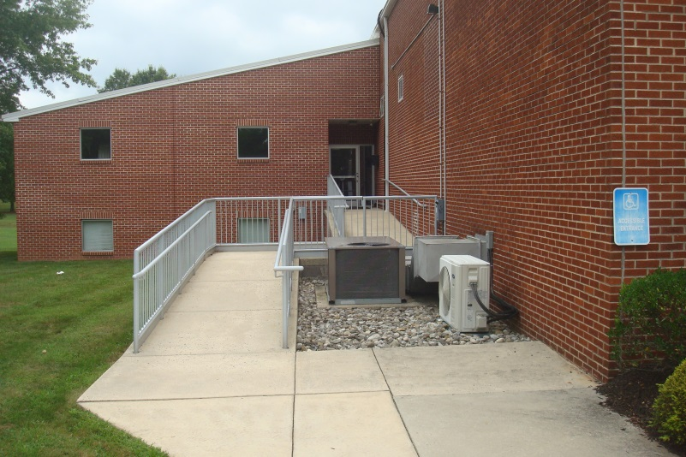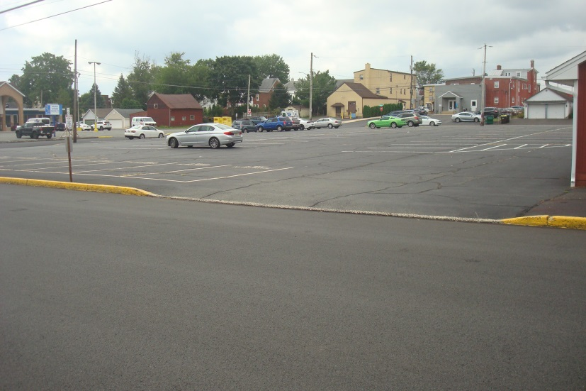

Secondary parking behind hall
